**A PROJECT REPORT**

**ON**

**Expense Income Tracker**

**FYMCA SEMESTER I**

**COURSE: MCA7PM02A-DISCRETE MATHEMATICS**

**Submitted By**

**1132230316 Bhavesh Hiray**

**1132232052 Martin S**

**1132232052 Aniket Damare**

**1132232041 Vaibhav Pathak**

**IN PARTIAL FULFILLMENT OF**

**MASTER OF COMPUTER APPLICATION (SCIENCE)**

**Submitted Through**

**Department of Computer Science and Applications To**

**DR. VISHWANATH KARAD MIT WORLD PEACE**

**UNIVERSITY, PUNE, MAHARASHTRA, INDIA -411038**

**DEPARTMENT OF COMPUTER SCIENCE AND APPLICATIONS**

Certificate

This is to certify that **Bhavesh Hiray, Martin S, Aniket Damare, and Vaibhav Pathak** students of MCA (Science) Semester I has/have successfully / partially completed the project on MCA7PM02A- Discrete Mathematics in partial fulfilment of MCA (Science) Sem I under Dr. Vishwanath Karad MIT World Peace University, for the academic year 2023-2024.



Dr. Anuradha Kanade

# Internal Guide

Dr. Jalindar Gandal Dr. Rajeshree Khande

# Program Head Program Director

Date: / /

External Examiners:

1.

2.

**ACKNOWLEDGEMENT**

The successful development of the Expense Income Tracker project has been a collaborative effort, and we extend our gratitude to various individuals and resources who have significantly contributed to its completion. We appreciate Dr Anuradha Kanade, our project supervisor, for their guidance and mentorship, which played a pivotal role in shaping the direction and quality of our work. Thanks to our peer collaborators for their active participation in discussions, code reviews, and shared insights that enriched the project's development process. Their collaborative spirit has been instrumental in overcoming challenges and fostering a positive working environment. We also recognize the contributions of the online community, forums, and resources that provided solutions to challenges and best practices.

The shared knowledge significantly enhanced the functionality and efficiency of our project. Our gratitude extends to the developers and contributors behind the open-source libraries and tools utilized in our project, which have been integral to its success and functionality. We are thankful for the support and understanding of our family and friends throughout the development journey. Their encouragement and patience have been a constant source of inspiration. The GitHub community and its contributors have played a vital role in inspiring and informing our project. The open-source ethos of the community has been a driving force behind the continuous improvement of our project. In conclusion, we extend our sincere thanks to everyone who has been a part of this collaborative and enriching experience, contributing to the realization of the Expense Income Tracker project.

**DECLARATION**

I hereby affirm that the Expense Income Tracker Project is the product of collective ideation sourced from the internet and has been collaboratively developed with the assistance of a group. This endeavor represents our original work, and I assert that it has not been previously submitted to any institution for the purpose of obtaining a degree, diploma, or certificate.

Throughout the development process, we have diligently cited all sources of information and data, ensuring proper acknowledgment in accordance with academic standards. This project stands as the result of our collective intellectual efforts and research, and in instances where external contributions have been integrated, due credit has been attributed.

We affirm our commitment to upholding the ethical guidelines set forth by our institution during the conception and realization of this project.

**Table Of Contents**

|  |  |
| --- | --- |
| **SR. NO** | **TOPIC** |
| **1** | Introduction |
| **2** | Project Scope |
| **3** | Objectives |
| **4** | Environment Description |
| **5** | Analysis |
| **6** | Design Report (Input and Output) |
| **7** | Limitations |
| **8** | Future Enhancement |
| **9** | Conclusion |
| **10** | References |

|  |  |  |
| --- | --- | --- |
|  |  |  |
|  |  |  |

**INTRODUCTION**

Managing personal finances is a crucial aspect of achieving financial well-being and stability. In the quest for fiscal responsibility, an Expense-Income Tracker emerges as an indispensable tool. This innovative solution serves as a digital companion, empowering individuals to meticulously monitor their financial inflows and outflows. The Expense-Income Tracker is designed to provide users with a comprehensive and user-friendly platform to record, categories, and analyze their expenses and income sources.

By seamlessly integrating into daily life, this tracker offers real-time insights into financial habits, enabling users to make informed decisions about budgeting, savings, and investment. Through its intuitive interface and customizable features, the Expense-Income Tracker ensures a tailored and efficient financial management experience. Whether tracking monthly expenditures, identifying spending patterns, or setting budgetary goals, this tool becomes a valuable ally in the journey toward financial health.

In a world where financial literacy is paramount, the Expense-Income Tracker stands out as an accessible and practical solution, empowering individuals to take control of their finances and embark on a path of informed financial decision-making. With its user-centric design and analytical capabilities, this tool becomes an invaluable asset in the pursuit of financial well-being.

**PROJECT SCOPE**

The project aims to develop a comprehensive Expense-Income Tracker application, providing individuals and businesses with a user-friendly platform to manage and analyze their financial activities. Key features include expense tracking, income categorization, budgeting tools, goal setting, detailed financial reports, and real-time analytics. The application will be accessible across various devices, ensuring a responsive design and compatibility with web browsers, iOS, and Android platforms. Security measures, including data encryption and regular backups, will be implemented to safeguard user information. Continuous collaboration with stakeholders, user feedback sessions, and adherence to industry standards will be integral to the project's success. Ongoing maintenance and support will be provided to address bug fixes, updates, and user requirements, positioning the Expense-Income Tracker as a valuable tool for informed financial decision-making.

**OBJECTIVES**

**1. Efficient Financial Management:**

Enable users to efficiently manage their financial resources by providing a centralized platform for tracking both expenses and income.

**2. Real-time Financial Insights:**

Offer real-time insights into spending habits, income sources, and overall financial health, empowering users to make informed financial decisions.

**3. Expense Categorization and Tracking:**

Facilitate the systematic recording and categorization of daily, monthly, and yearly expenses to provide a clear overview of where money is being spent.

**4. Income Source Diversification:**

Assist users in categorizing and tracking various sources of income, fostering a comprehensive understanding of their financial inflows.

**5. Budgeting and Goal Achievement:**

Support users in setting budget limits for different expense categories, promoting responsible spending, and aiding in the achievement of financial goals.

**6. Data-driven Decision Making:**

Provide analytical tools and reports that allow users to analyze spending patterns, identify trends, and make data-driven decisions to enhance financial well-being.

**7. User-friendly Interface:**

Design an intuitive and user-friendly interface to ensure ease of use, accessibility, and a positive user experience for individuals of varying financial literacy levels.

**8. Customization for Personalization:**

Allow users to customize expense categories and income sources, tailoring the tracker to individual lifestyles and financial priorities.

**9. Security and Privacy:**

Prioritize the implementation of robust security measures and data encryption to safeguard sensitive financial information, ensuring user privacy and trust.

**Environment Description**

The Expense and Income Tracker project was developed using a robust and versatile development environment to ensure efficiency and compatibility. The key components of the development environment include:

Programming Language: Java

Integrated Development Environment (IDE): IntelliJ IDEA & VS Code

Graphical User Interface (GUI) Library: Java Swing

- The project's graphical user interface (GUI) was developed using Java Swing, a user interface toolkit for Java applications. Swing provides a set of components for building a rich and interactive user interface.

Look and Feel Library: FlatLaf

- To enhance the visual aesthetics and provide a modern appearance, the FlatLaf look and feel library were integrated into the project. FlatLaf is known for its sleek design and compatibility with Swing applications.

Data Presentation: Java Swing Table

- The presentation and management of financial entries are handled using Java Swing's JTable component. This component facilitates the organization and display of data in a tabular format.

Version Control:

- GitHub: The project's source code is hosted on GitHub, a web-based platform for version control using Git. GitHub provides collaboration features, code review, and a centralized repository for the project.

Operating System:

- Platform-Independent: The project is designed to be platform-independent, ensuring compatibility with various operating systems such as Windows, macOS, and Linux.

Conclusion: The Expense and Income Tracker project leverages a robust development environment, making use of Java, Swing, and additional libraries to create a seamless and visually appealing financial management application. The choice of tools and technologies was guided by their compatibility, feature sets, and the project's overall requirements.

**ANLYSIS**

**1. Market Demand:**

- There is a growing demand for personal finance management tools, driven by increasing awareness of financial literacy and the need for individuals to gain control over their spending habits.

- The market is competitive, but the demand for a user-friendly, comprehensive Expense-Income Tracker presents an opportunity for a well-designed and feature-rich application.

**2. User Needs and Pain Points:**

- Users require a solution that seamlessly integrates expense and income tracking, allowing for a holistic view of their financial health.

- Pain points include the lack of intuitive tools for categorizing expenses, limited income tracking options, and the absence of real-time insights into spending patterns.

**3. Target Audience:**

- The primary target audience includes individuals seeking a user-friendly tool for managing personal finances, as well as small businesses or freelancers looking for an adaptable solution for expense and income tracking.

**4. Competitor Landscape:**

- Competitors in the personal finance management space offer a range of applications with varying features and interfaces.

- Identifying unique selling points and differentiating factors, such as advanced analytics, customization options, and cross-platform accessibility, will be crucial.

**5. Technological Landscape:**

- Utilizing modern web development technologies and frameworks ensures scalability, responsiveness, and compatibility with various devices.

- Integration capabilities with existing financial tools and banking systems will enhance the application's utility.

**6. Regulatory Considerations:**

- Adherence to data protection regulations and financial industry standards is paramount to establishing trust among users.

- Clear communication and transparency regarding data security measures will address regulatory concerns.

**Design Report (Input and Output)**

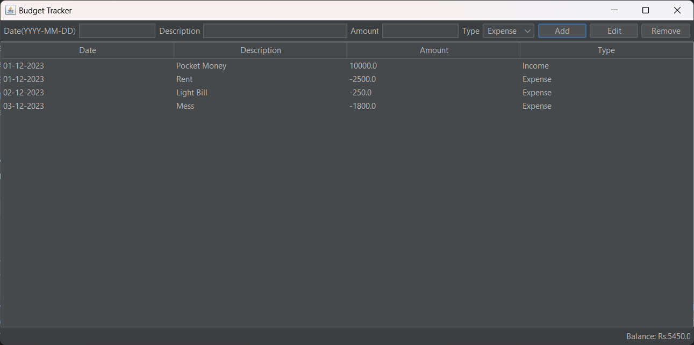

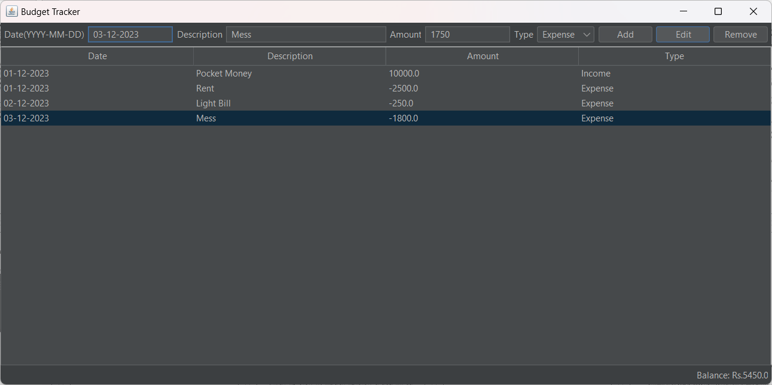

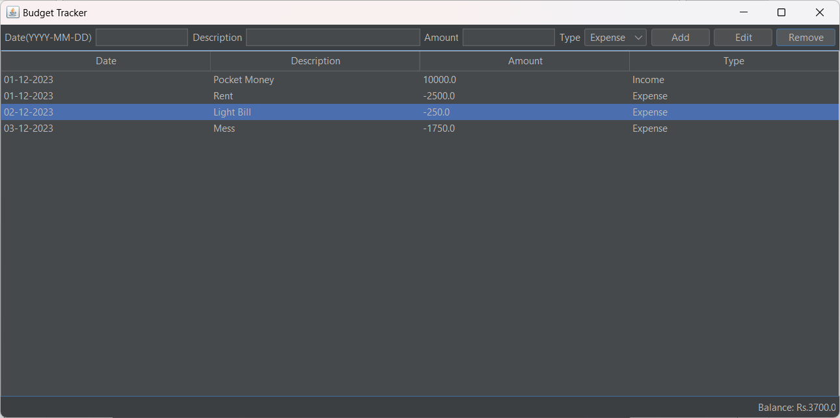

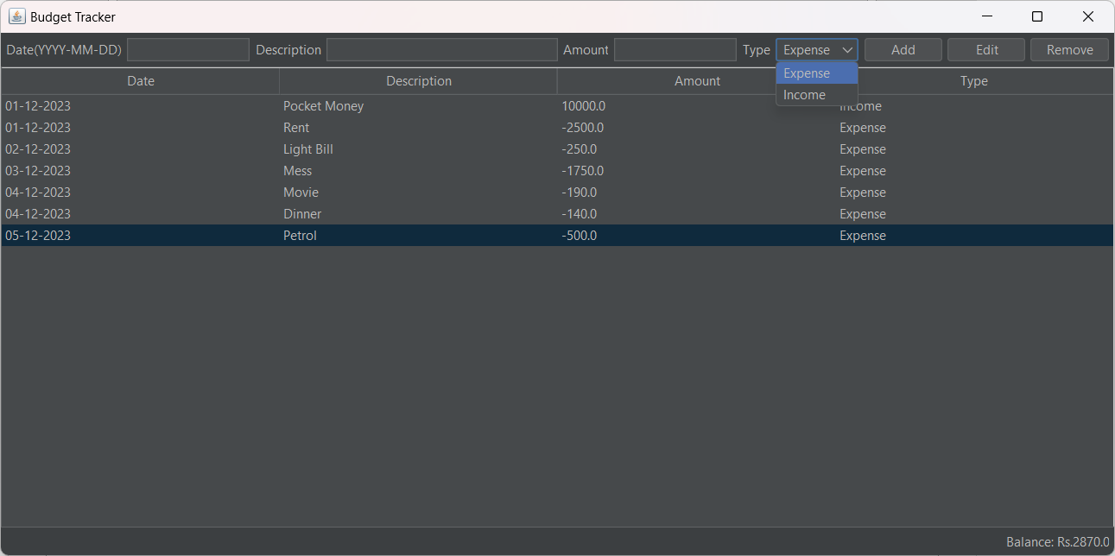

**LIMITATIONS**

**1. Dependency on User Input:**

- The accuracy and effectiveness of the Expense-Income Tracker heavily rely on users consistently inputting their financial data. Incomplete or inaccurate data entry can compromise the reliability of the insights generated by the application.

**2. Limited Integration with Financial Institutions:**

- While the Expense-Income Tracker aims to provide a comprehensive financial overview, limitations in integrating with various financial institutions may result in manual data entry for certain transactions, reducing automation and convenience.

**3. Security Concerns:**

- Despite robust security measures, the inherent risk of cybersecurity threats and potential data breaches exists. Users must be vigilant in safeguarding their login credentials, and the project must stay updated with the latest security protocols to mitigate risks.

**4. Privacy Issues:**

- Users may be hesitant to input sensitive financial information into the Expense-Income Tracker due to privacy concerns. Clear communication regarding data privacy measures is essential to build and maintain user trust.

**5. Assumption of Regular Internet Connectivity:**

- The application's effectiveness relies on a stable Internet connection for real-time updates and synchronization. Users without consistent internet access may experience limitations in accessing and updating their financial data.

**6. Device Compatibility:**

- While efforts may be made to ensure cross-platform accessibility, certain devices or operating systems may not fully support all features. This can result in a varied user experience across different devices.

**7. Scalability Challenges:**

- As the user base grows, the Expense-Income Tracker may face scalability challenges, leading to performance issues. Continuous monitoring and adjustments to infrastructure may be necessary to accommodate increased demand.

**Future Enhancement**

1. Integration with Financial Institutions: Enhance automation by enabling direct integration with banks and financial institutions for seamless transaction syncing.

2. AI-driven Insights: Implement artificial intelligence algorithms to provide personalized financial insights and predictive analytics based on user spending patterns.

3. Multi-Currency Support: Expand functionality to accommodate multiple currencies, catering to users with diverse international financial transactions.

4. Automated Bill Payments: Integrate features for automated bill payments, allowing users to set up recurring payments directly within the application.

5. Enhanced Security Features: Implement advanced security measures, such as biometric authentication and multi-factor authentication, to fortify user data protection.

6. Smart Budget Recommendations: Utilize machine learning algorithms to analyze spending habits and provide intelligent budget recommendations aligned with users' financial goals.

7. Integration with Investment Platforms: Extend the application's capabilities by integrating with investment platforms, allowing users to track and manage their investment portfolios.

8. Collaborative Budgeting: Enable collaborative budgeting features, allowing families or teams to collectively manage and track shared expenses.

9. Enhanced Report Customization: Provide users with more options to customize and generate detailed financial reports, catering to specific analysis needs.

10. Tax Planning Tools: Incorporate tax planning functionalities, helping users optimize their financial decisions with a focus on tax implications.

These future enhancements aim to evolve the Expense-Income Tracker into a more sophisticated and adaptive financial management tool, providing users with advanced features and capabilities for holistic financial control.

**CONCLUSION**

In conclusion, the Expense-Income Tracker project proves to be a crucial tool for managing personal and business finances. It offers a thorough and intuitive framework in an effort to tackle the core elements of fiscal control. With features like exact income classification, thorough spending tracking, and real-time analytical capabilities, the application aims to provide organizations and people with useful information for wise financial decision-making.

The project's commitment to ensuring the security and privacy of user data is paramount, with robust measures like data encryption and regular backups integrated into its framework. The emphasis on cross-platform accessibility, spanning web browsers, iOS, and Android platforms, underscores the project's commitment to reaching a diverse user base and accommodating varied preferences.

Moreover, the Expense-Income Tracker is positioned as a dynamic, ever-evolving entity that responds to the changing needs of its users thanks to the continual collaboration with stakeholders and user feedback sessions. The project's commitment to not just meeting but also surpassing user expectations is seen in its engagement and flexibility strategies.

In summary, the goal of the Expense-Income Tracker is to provide users with a comprehensive and powerful experience in managing their financial well-being, thereby positioning it as a dynamic force in the financial technology scene. The project strives to anticipate and satisfy users' future needs in the constantly changing realm of personal and company finance through its features, security protocols, and ongoing evolution.

**REFERENCES**

1. Java Programming Language:

- Oracle. (n.d.). Java Platform, Standard Edition Documentation. [https://docs.oracle.com/en/java/](https://docs.oracle.com/en/java/)

2. IntelliJ IDEA (IDE):

- JetBrains. (n.d.). IntelliJ IDEA. [https://www.jetbrains.com/idea/](https://www.jetbrains.com/idea/)

3. Java Swing GUI Library:

- Oracle. (n.d.). Java Swing Documentation. [https://docs.oracle.com/javase/tutorial/uiswing/](https://docs.oracle.com/javase/tutorial/uiswing/)

4. FlatLaf Look and Feel Library:

- FormDev. (n.d.). FlatLaf - Flat Look and Feel for Java (GitHub Repository). [https://github.com/JFormDesigner/FlatLaf](https://github.com/JFormDesigner/FlatLaf)

5. Java Swing Table Component:

- Oracle. (n.d.). How to Use Tables. [https://docs.oracle.com/javase/tutorial/uiswing/components/table.html](https://docs.oracle.com/javase/tutorial/uiswing/components/table.html)

6. iText Library (Optional - for PDF Export):

- iText Software. (n.d.). iText - Free and Open Source PDF Library. [https://itextpdf.com/](https://itextpdf.com/)

7. GitHub Version Control:

- GitHub. (n.d.). GitHub Docs. [https://docs.github.com/](https://docs.github.com/)